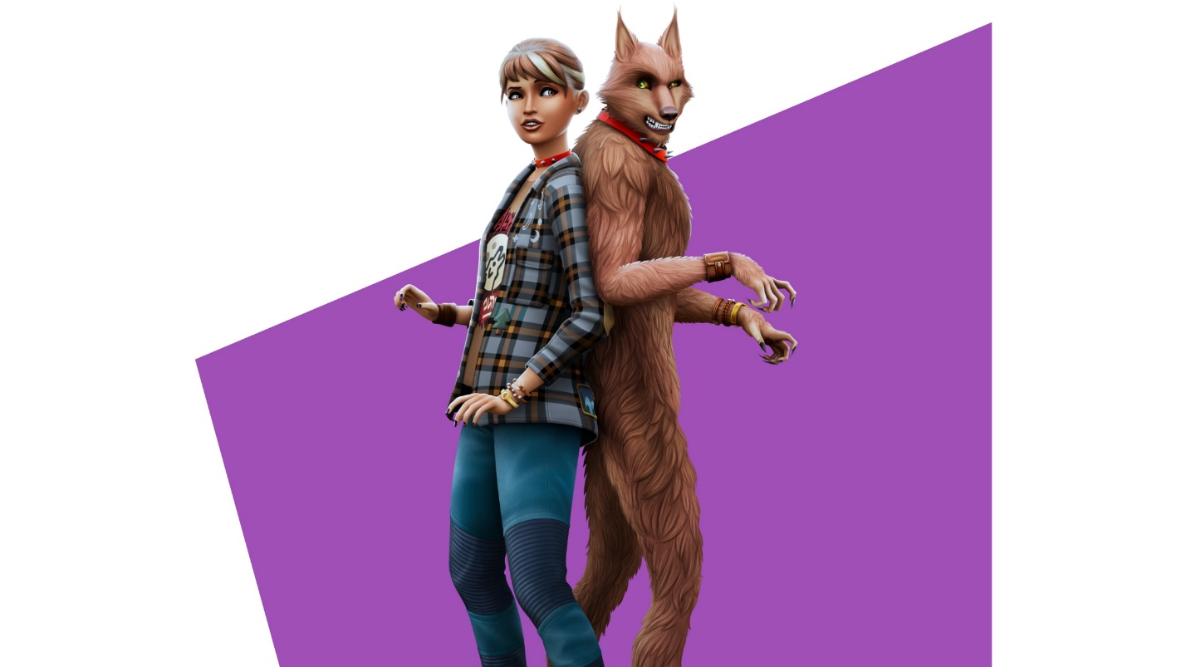

##### **The Sims™ 4:WEREWOLVE**

## ***Life on the Wild Side:***

## https://www.ea.com/_next/image?url=https%3A%2F%2Fdrop-assets.ea.com%2Fimages%2F5A1VXaC4puW99TXHi6SkD9%2F719d586e06bbdd17a7eb7d7026d513d5%2FTS4_Werewolves_Media-Hero-Tile_16x9_01.jpg&w=3840&q=75

What big teeth you’ll have! Transform into a werewolf and embrace (or fight) your animalistic nature. Beyond rocking a fearsome form werewolf Sims will have unique temperaments and abilities, be affected by the phase of the moon, and experience wolf-specific life events.